Graduate Mathematics Seminar

Understandings of Functions Amongst
Math vs Liberal Studies

Archana Thakur
California State University, Channel Islands

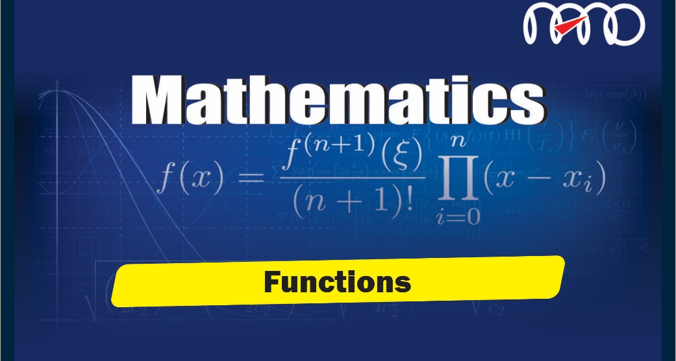

Abstract: Research suggests that many undergraduate mathematics students struggle with understanding fundamental function ideas. Since functions are a foundational element for learning Calculus, a partial understanding of functions may affect a student’s ability to succeed in Mathematics courses and may have negative repercussions for the involvement of students in STEM fields and careers. More generally, understanding basic function ideas is essential to daily life activities. In this study, I present an emergent framework for understanding undergraduate students’ notions of function. The study participants included math and non-math majors in an effort to characterize the variations in their understandings. Based on the results, possible recommendations for teaching functions will also be presented.

When: Monday, September 27, 2021, 6:00 – 7:00 pm

