Graduate Mathematics Seminar

Reinforcement Learning and How to Use it to Automate the Population Pharmacokinetics Model Building Process.
Julian David Otálvaro
Children's Hospital Los Angeles

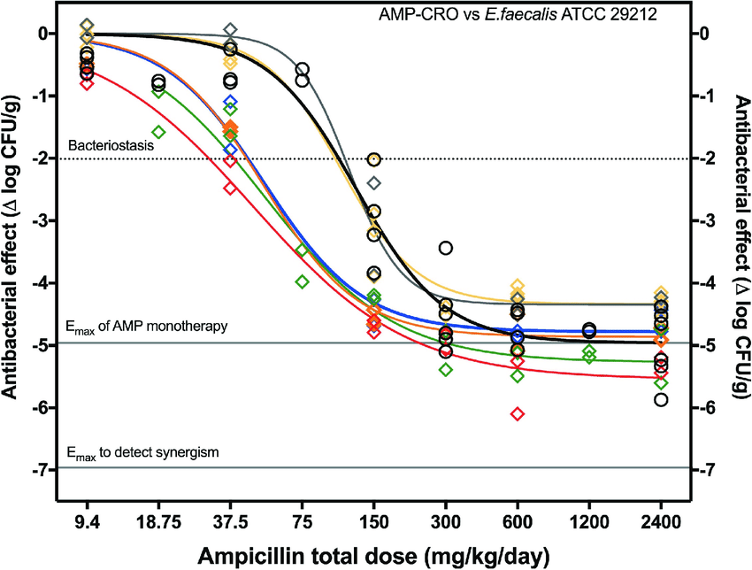

Abstract: The building of population pharmacokinetic models can be described as an iterative process in which given a model and a dataset, the pharmacometrician performs introduces some changes, then perform an evaluation and based on the predictions obtained performs further optimization. This process (perform an action, witness a result, optimize your knowledge) is a perfect scenario for the implementation of a Reinforcement Learning algorithm. By doing this we expect to reduce the burden over the modeler’s shoulders, by giving them a tool they can set up to automate (to a certain point) the iterative model building process.

When: Monday, November 15, 2021, 6:00 – 7:00 pm
Where: Zoom

