Graduate Mathematics Seminar

Theoretical considerations: Polynomial Regression and Feed Forward Neural Networks correspondence

Victoria Lam
California State University, Channel Islands

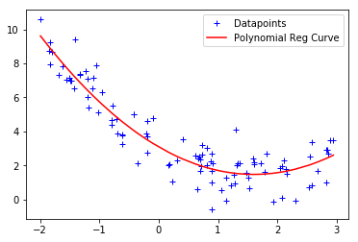

Abstract: In 2019, X. Cheng, B. Khomtchouk, N. Matloff, & P. Mohanty published a paper "Polynomial Regression as an Alternative to Neural Nets," which proposed a theoretical correspondence between the output models of these two learning methods. The authors did not provide a formal proof for this correspondence; however, by the end of 2019, their manuscript received citations by publications from a variety of fields, ranging from quantum information theory to biomechanics to linguistics. We investigate the theoretical justification for the informal argument suggested by the authors of this paper.

When: May 11th, 2020, 6:00 - 7:00 pm
Where: https://csuci.zoom.us/j/7214277893

