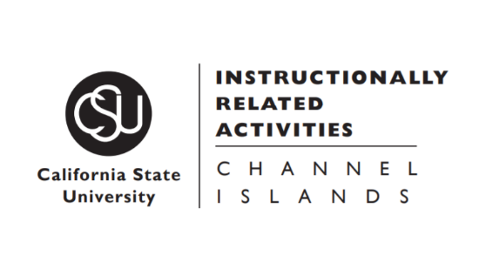
You are invited ...

Math Seminar, October 11, 2021, Monday 4:30 pm

Title: Relatively Prime Densities

Vickie Chen, California Lutheran University
Abstract: From relatively prime densities to graph-wise relatively prime densities, we will explore some number theoretic ideas involving primality as well as discuss success in graduate school.

Zoom link

https://csuci.zoom.us/j/85943294735

